­./

GENESIS - Learning Outcome & Mini-project Summary Report



|  |  |  |  |  |  |
| --- | --- | --- | --- | --- | --- |
| **Ver. Rel. No.** | **Release Date** | **Prepared. By** | **Reviewed By** | **To be Approved** | **Remarks/Revision Details** |
| 1 | 09/11/2020 | Asha N |  |  |  |
|  |  |  |  |  |  |
|  |  |  |  |  |  |
|  |  |  |  |  |  |
|  |  |  |  |  |  |

**Details**

Contents

Miniproject -1 [Team/Individual] 5

Title : Doctor Appointment System 5

1. Module/s Used 5

1.1 Topic and Subtopics 5

2. Objectives & Requirements 5

2.1 High level requirements 5

2.2 Low level requirement 6

3. Design 6

3.1 Class Diagram 6

3.2 Activity Diagram 7

3.3 Component Diagram 8

3.4 Use Case Diagram 9

4. Test Plan 9

4.1 Unit Testing 9

4.2 Integration Testing 10

5. Implementation Summary 10

5.1 Git link 10

5.2 Git Dashboard 11

5.3 Summary 11

6.Individual Contribution & Highlights 16

7. Challenges faced and how were they overcome 16

7.1 Future Scope 16

Miniproject -2 [Team/Individual] 17

Title : Matrix Multiplication Using Multithreading 17

1. Module/s Used 17

Mini project is related to linux and OS programming using C programming. 17

1.1 Topic and Subtopics 17

2. Objectives & Requirements 17

3. Implementation Summary 17

3.1 Git Link 17

3.2 Git Dashboard 18

4.3 Summary 21

5. Individual Contribution & Highlights 21

5.1 Issues in Codacy 21

5.2 Challenges faced and how were they overcome 21

Miniproject -3 [Team/Individual] 22

Title : Top Women Chess Players 22

1. Module/s Used 22

2. Objectives & Requirements 22

2.1 Requirements 22

2.1.1 High level requirements 22

2.1.2 Low level requirements 22

3. Design 23

3.1 Class Diagram 23

3.2 Use Case Diagram 24

4. Implementation Summary 24

4.1 Git link 24

4.2 Git Dashboard 25

4.3 Summary 25

5. Individual Contribution & Highlights 30

5.1 Challenges faced and how were they overcome 30

5.2 Future Scope 30

6. REFERENCES 30

**Table of Figures**

Figure 1 : Class Diagram

Figure 2 : Activity Diagram

Figure 3 : Component Diagram

Figure 4 : Use case Diagram

Figure 5 : Git Dashboard

Figure 6 : Git Inspector

Figure 7 : Build

Figure 8 : Badges

Figure 9 : Issues

Figure 10 : Unit Testing

Figure 11 : Git Dashboard

Figure 12 : Git Inspector

Figure 13 : Build

Figure 14 : Issues in Codacy

Figure 15 : Class Diagram

Figure 16 : Use case Diagram

Figure 17 : Git Dashboard

Figure 18 :Git Inspector

Figure 19 : Build

Figure 20 : Code Coverage

Figure 21 : Pylint

# Miniproject -1 [Team/Individual]

## **Title : Doctor Appointment System**

## **1.** **Module/s Used**

Modules linked to the miniproject are Linux, SDLC and C++.

C++:

C++ is a general-purpose programming language created by Bjarne Stroustrup as an extension of the C programming language, or "C with Classes.

SDLC:

Software Development Life Cycle (SDLC) is a framework that defines the steps involved in the development of software at each phase. It covers the detailed plan for building, deploying and maintaining the software.

### 1.1 Topic and Subtopics

* CSV file
* Class and Object-OOP in C++.
* Google test(Unit test)
* Make file
* SDLC and TDLC
* Polymorphism
* Operator overloading
* STL containers.
* Code Quality(Codacy)

## **2.** **Objectives & Requirements**

### 2.1 High level requirements

|  |  |
| --- | --- |
| **ID** | **Description** |
| HL_01 | Analysis of patient details. |
| HL_02 | Comparison of different diseases |
| HL_03 | Highest and lowest aged patients. |
| HL_04 | Adding new patient details |

### 2.2 Low level requirement

|  |  |
| --- | --- |
| **ID** | **Description** |
| LL_01 | Reading data from csv file. |
| LL_02 | Saving all data on list using STL concepts |
| LL_03 | Implementation of CI/CD. |

## **3.** **Design**

### 3.1 **Class Diagram**

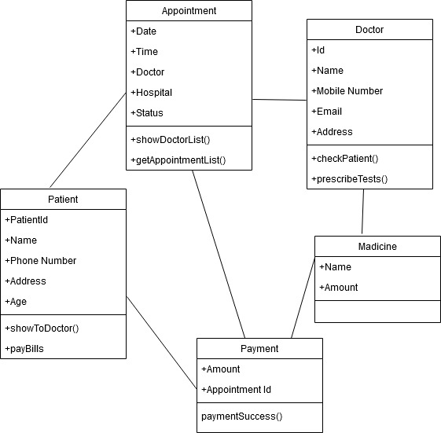

Figure 1 : Class Diagram

### **3.2 Activity Diagram**

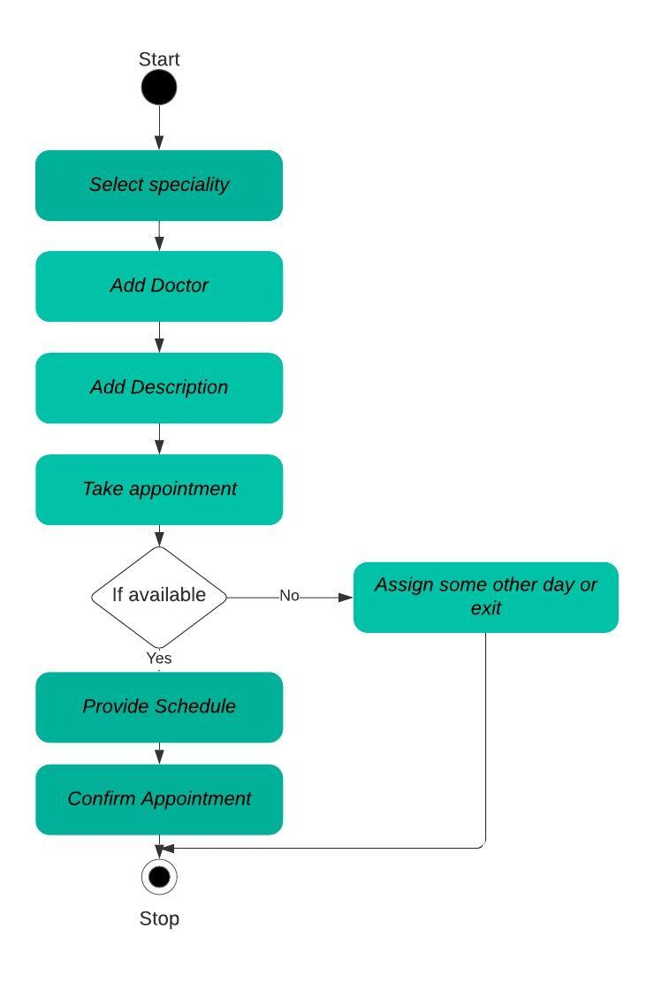

Figure 2 : Activity Diagram

### **3.3 Component Diagram**

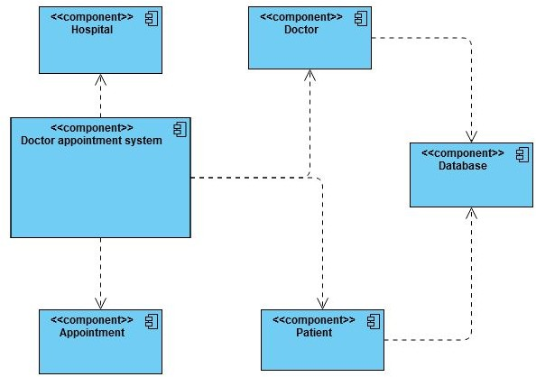

Figure 3 : Component Diagram

### **3.4 Use Case Diagram**

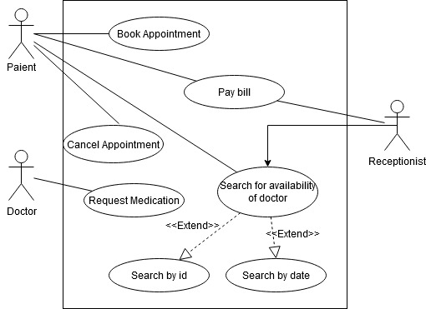

Figure 4 : Use case Diagram

## **4.** **Test Plan**

### **4.1 Unit Testing**

|  |  |  |  |  |
| --- | --- | --- | --- | --- |
| Test id | Description | Expected input | Expected output | Actual output |
| HH_01 | Knowing of patient details. | Adding the data to list | Display of list where patient is added | Patient added |
| HH_02 | Analysis of different diseases | Checking of different diseases | Printing of different diseases | True |
| HH_03 | Highest aged patients | Giving patient name | Giving the highest aged patient name. | Year patient name |
| HH_04 | Adding of new patient | Adding of new patient | Display of list where new patient is added | True |

### **4.2 Integration Testing**

|  |  |  |  |  |
| --- | --- | --- | --- | --- |
| Test id | Description | Expected input | Expected output | Actual output |
| LL_01 | Reading of csv file | Csv file | Adding of all data present in csv to list | Data added to list |
| LL_02 | Adding data to list using STL concepts | Adding data to list | Data added to list | Display of list |
| LL_03 | CI/CD | GitHub Actions | Cppcheck, valgrind, unit testing , codacy | Passing all CI/CD |

## **5.** **Implementation Summary**

The implementation of this project is updated in the git repository “99002646/MiniProject_Cpp”

https://github.com/99002646/MiniProject_Cpp.git

### **5.1** **Git link**

**https://github.com/99002646/MiniProject_Cpp.git**

### 5.2 Git Dashboard

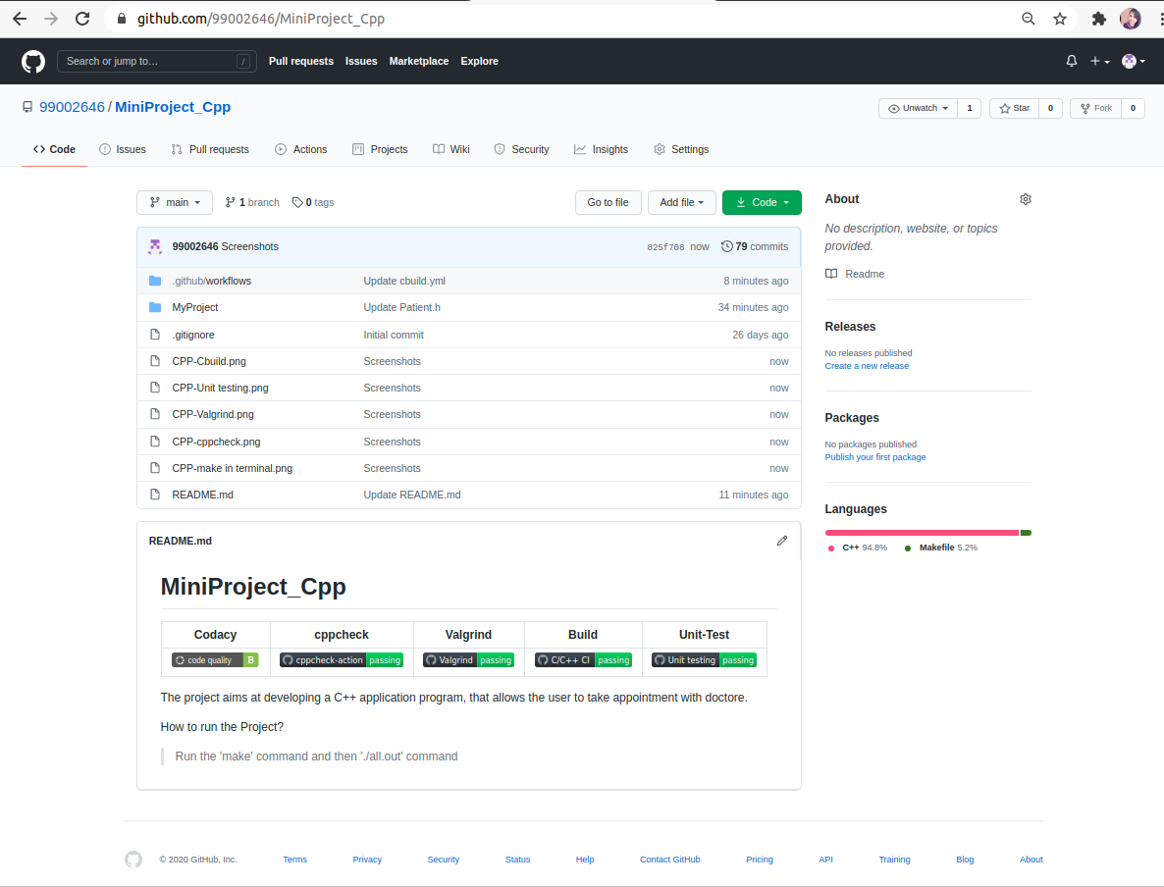Figure 5 : Git Dashboard

### 5.3 Summary

* The Doctor appointment system project is implemented using the C++.
* STL Concepts is used to work with the csv file.

#### Git inspector summary

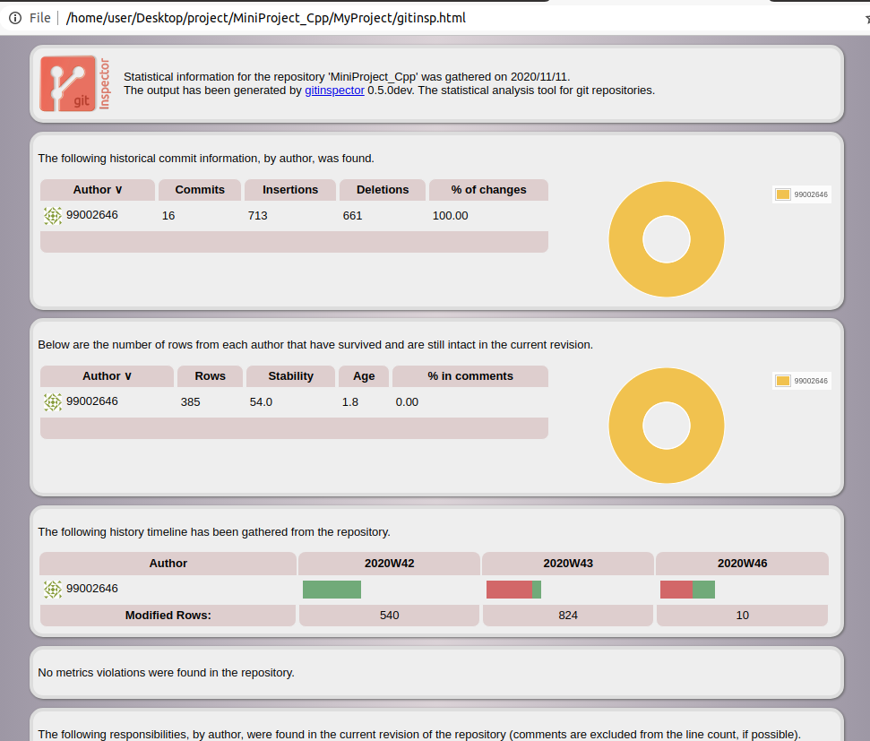Figure 6 : Git Inspector

#### Build

* Use Cmake to link all the files and generate the Makefile
* Execute generated Makefile
* run ./executeTests
* run valgrind ./executeTests to check for memory leaks

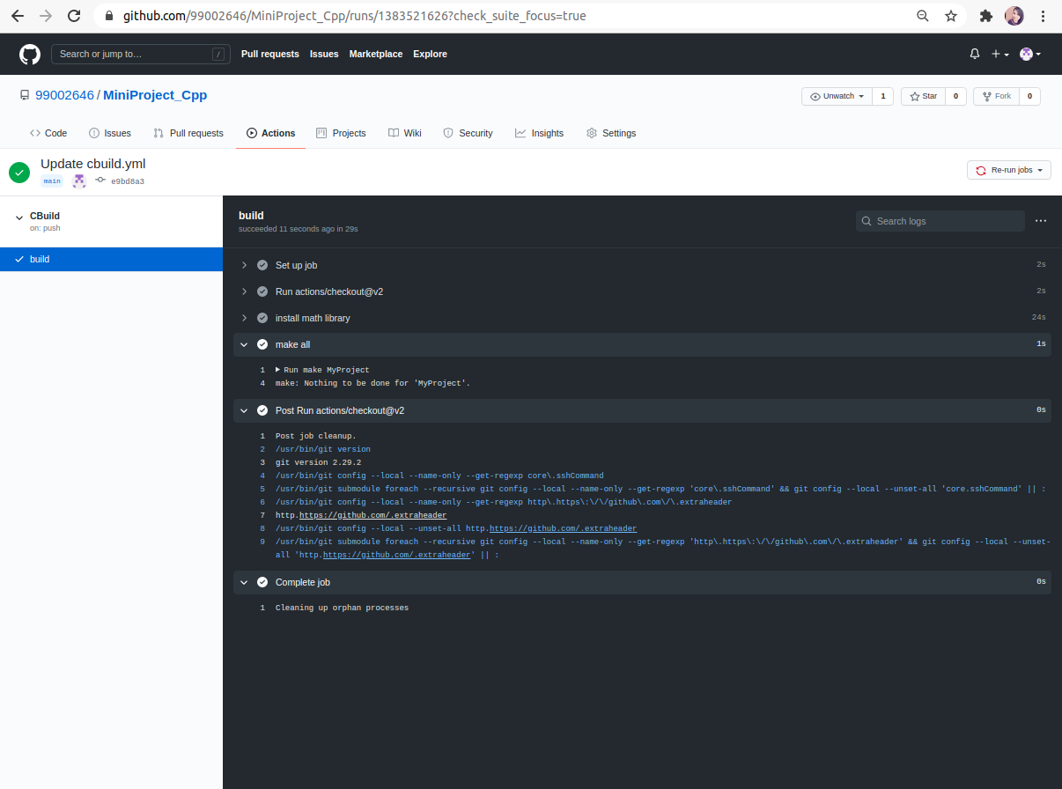Figure 7 : Build

#### Code quality and Issues or Bug Tracking

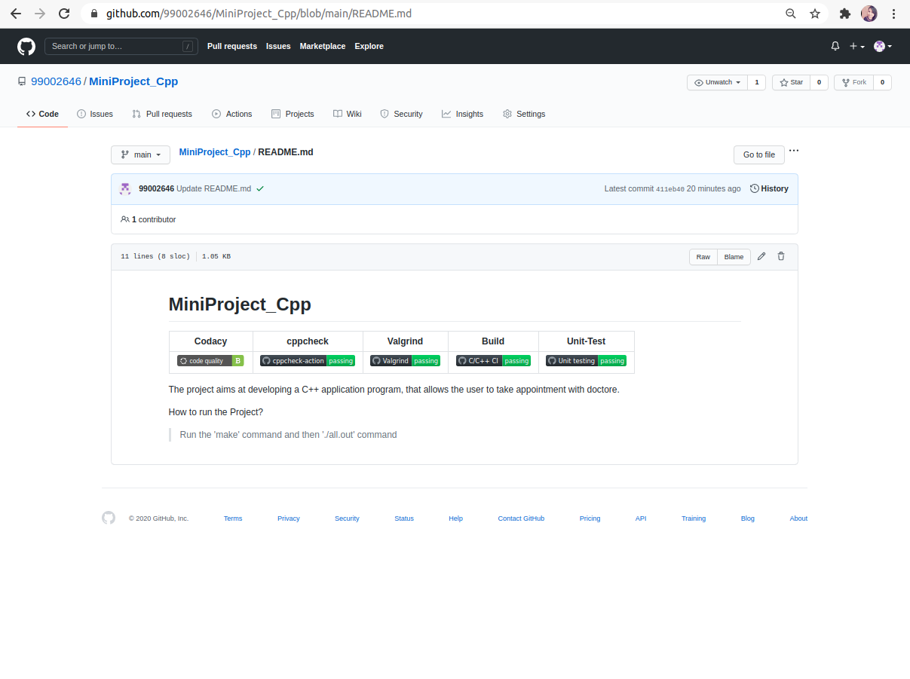Figure 8 : Badges

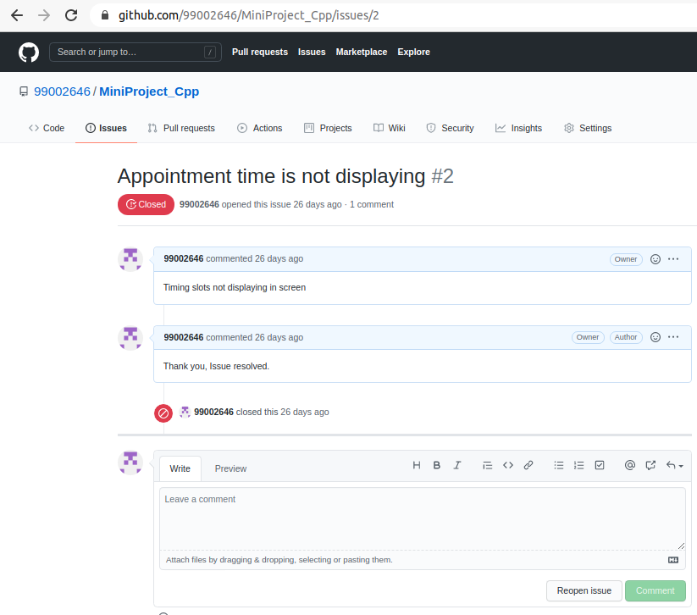Figure 9 : Issue

#### Unit Testing

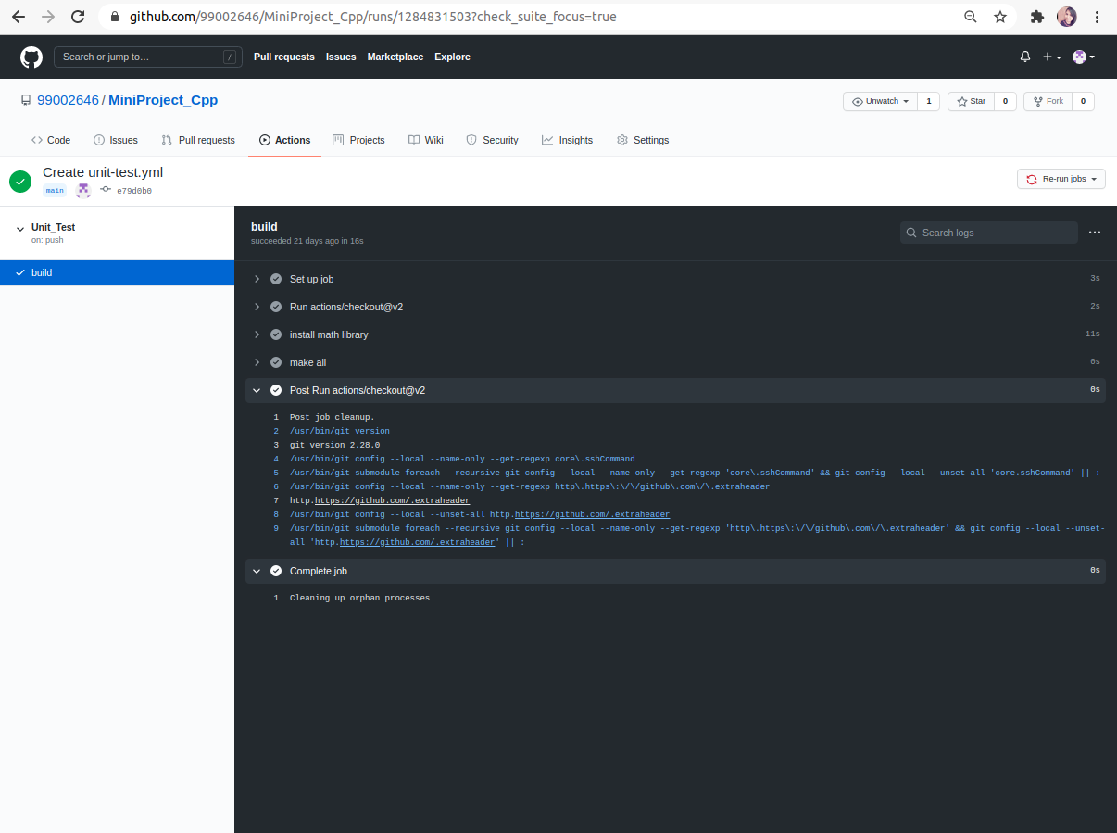Figure 10 :Unit Testing

## **6.****Individual Contribution & Highlights**

Not Applicable – Individual Project; Sole Collaborator.

## **7.** **Challenges faced and how were they overcome**

* While implementing the STL concepts like list, vector we have faced an issue to display the data from the Data set .
* We have overcome this problem by implementing it using the list as the containers.

### 7.1 Future Scope

* This project can be implemented further by upgrading the appointment schedule and analyzing the shows.

# Miniproject -2 [Team/Individual]

## **Title : Matrix Multiplication Using Multithreading**

## **1.** **Module/s Used**

## Mini project is related to linux and OS programming using C programming.

### 1.1 Topic and Subtopics

* Process, Threads and IPC
* File handling
* Multi threading

## **2.** **Objectives & Requirements**

* To perform the multiplication in multiple threads
* To decide the user to create number of threads
* reading the input from .txt file.

## **3.** **Implementation Summary**

The linux and OS programming project is updated in the git repository “99002646/MiniProject_Linux”

<https://github.com/99002646/MiniProject_Linux.git>

### 3.1 Git Link

<https://github.com/99002646/MiniProject_Linux.git>

### 3.2 Git Dashboard

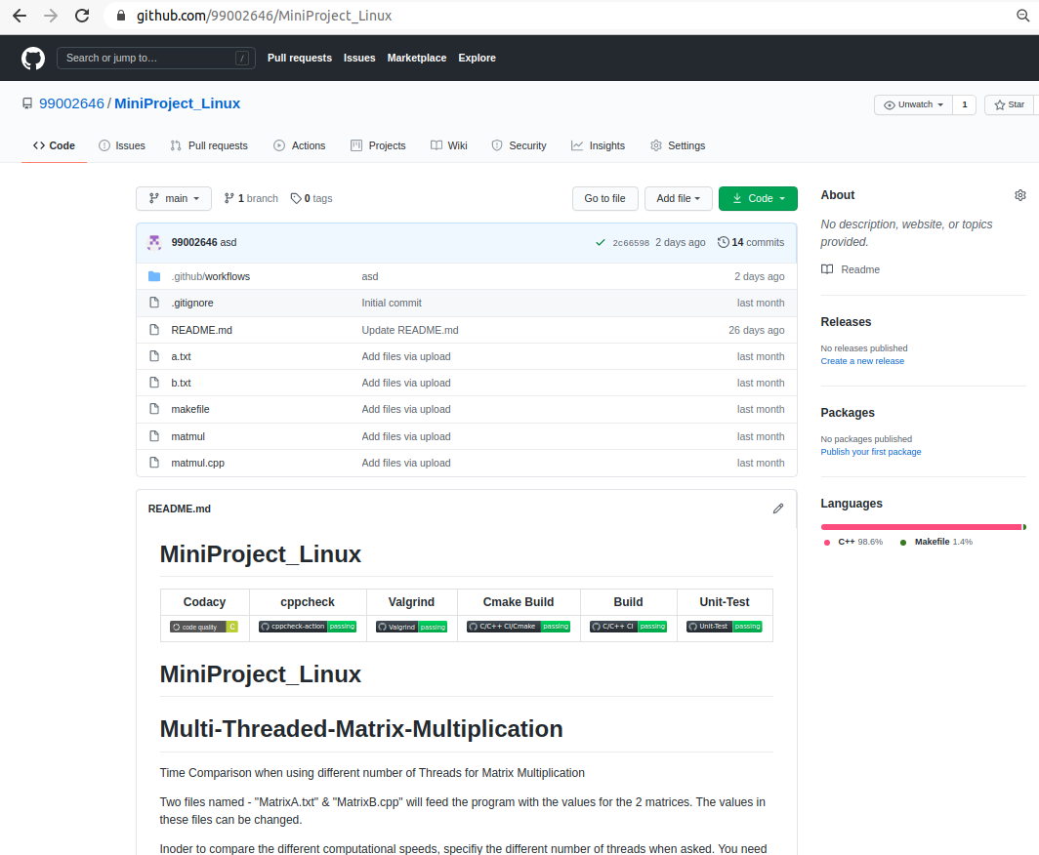Figure 11 : Git Dashboard

#### Git inspector summary

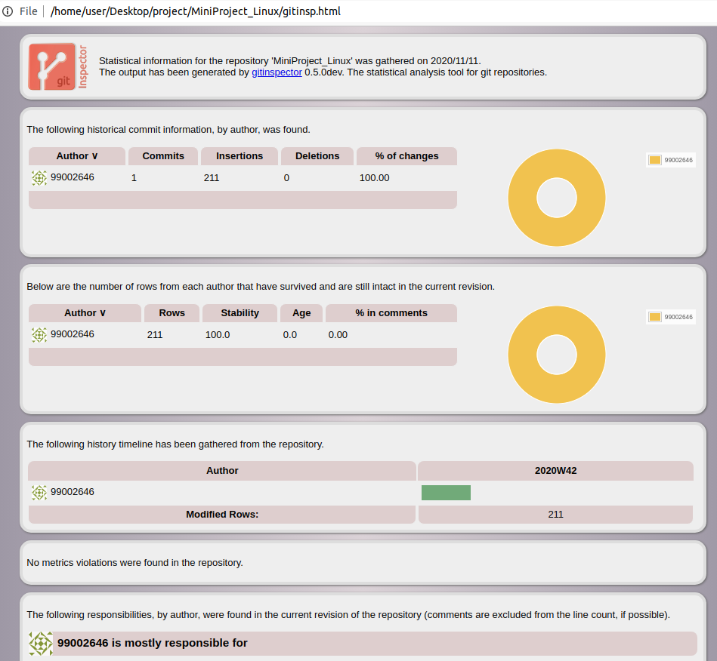Figure 12 : Git Inspector

#### Build

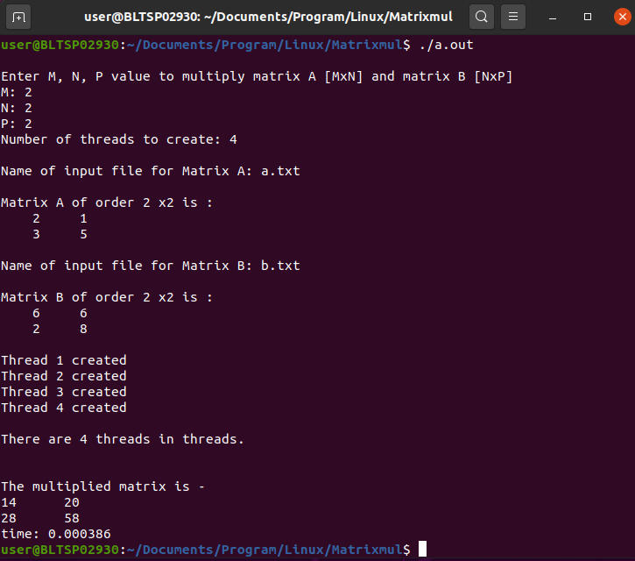Figure 13 : Build

#### Code quality

* Code Quality: Codacy: B Grade
* CppCheck: Passing
* C/C++ CI Build: Passing

## **4.** **Summary**

In this project we have not used any synchronization in future it can be implemented while serving the burger with many customer to maintain the process accurately.

## **5.** **Individual Contribution & Highlights**

Not Applicable – Individual Project; Sole Collaborator.

### 5.1 Issues in Codacy

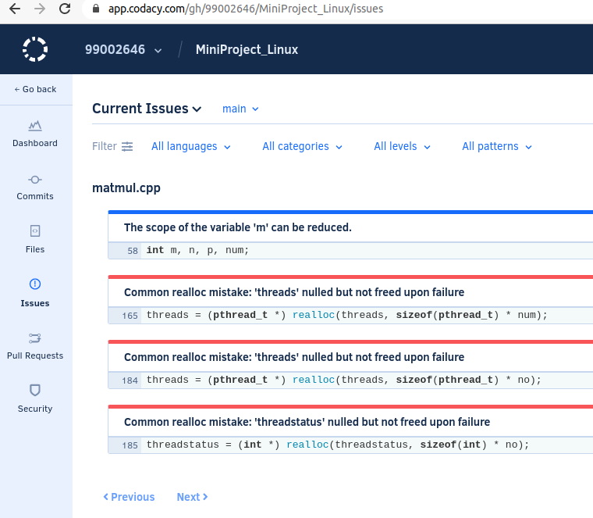Figure 14 : Issues in Codacy

### 5.2 Challenges faced and how were they overcome

While implementing the file handling concept we have faced some issues like reading error, file not found error, then resolved the issue.

# Miniproject -3 [Team/Individual]

## **Title : Top Women Chess Players**

## **1.** **Module/s Used**

Mini project is related to python.

## **2.** **Objectives & Requirements**

* The top women chess players analysis mini project has fide id, name of the player, title, date of birth, federation, standard rating, rapid rating, blitz rating columns.
* which helps to find the players by their fide id.
* It sorts the names, titles with the ascending and descending order.
* It calculates the standard rating, rapid rating, blitz rating and finds the maximum and minimum rating for the individual players.
* Counts the number of players in the given data set and group the players by their respective federation and region.

### 2.1 Requirements

### 2.1.1 High level requirements

-To Compute the minimum and maximum rating of the Top Chess players with standard rating, rapid rating and blitz rating.

-To Count the players by the Federation.

-To Compute the Maximum rating of the players.

### 2.1.2 Low level requirements

-To sort the names, titles of the players in the ascending and descending order.

-To find women players by the date of birth and federation name.

## **3.** **Design**

### 3.1 **Class Diagram**

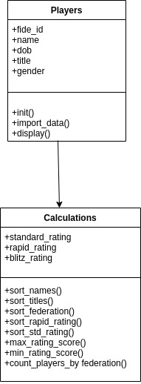

Figure 15 : Class Diagram

### **3.2 Use Case Diagram**

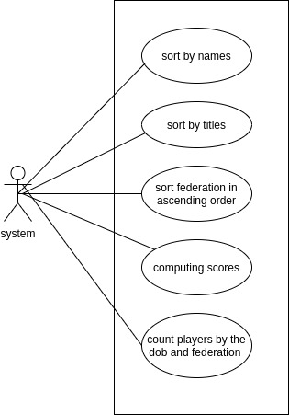

Figure 16 : Use case Diagram

## **4.** **Implementation Summary**

The implementation of this project is updated in the git repository “99002646/MiniProject_Python”

[https://github.com/99002646/MiniProject_Python.git](https://github.com/99002646/MiniProject_Cpp)

### **4.1** **Git link**

[https://github.com/99002646/MiniProject_Python.git](https://github.com/99002646/MiniProject_Cpp)

### 4.2 Git Dashboard

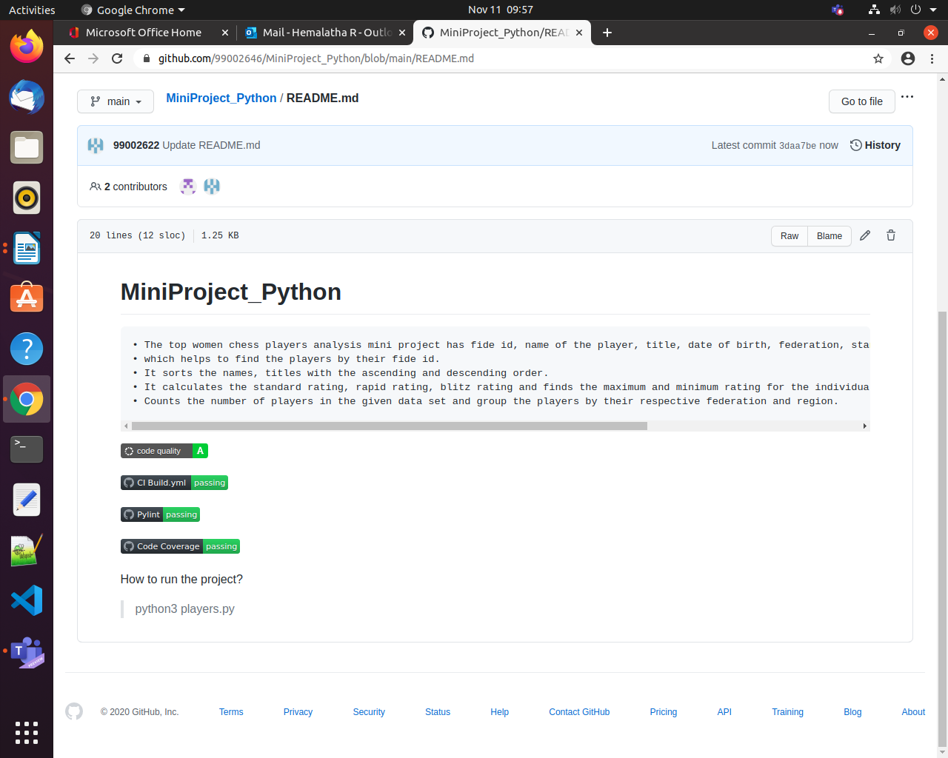

Figure 17 : Git Dashboard

### 4.3 Summary

* The Top women chess player analysis Project is implemented using the C++ which displays the players name, fide id, date of birth, gender, federation, Titles and ratings.
* STL Concepts is used to retrieve the DataSet.
* Here, we perform some of the functions like computing the ratings of all the three different ratings and displaying the maximum ratings of all the players.
* By using the Federation as the key displaying the players within that federation.
* Identifying the player using the Fide ID by using the Id as parameter.
* Finding total number of women players by using the count function in the dataset.

#### Git inspector summary

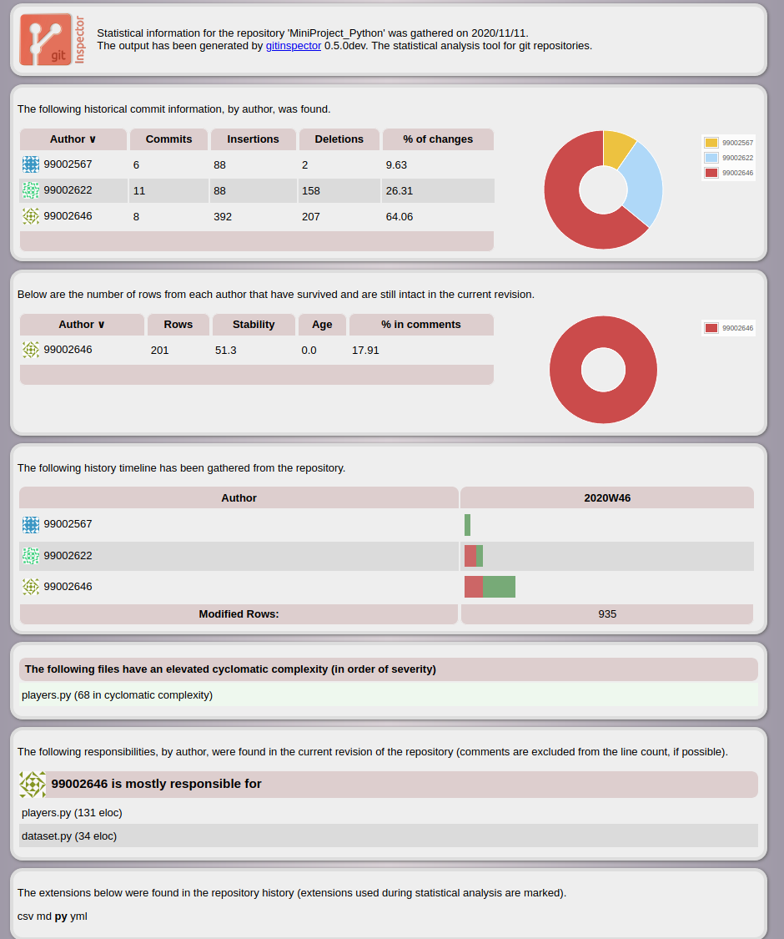

Figure 18 : Git Inspector

#### Build

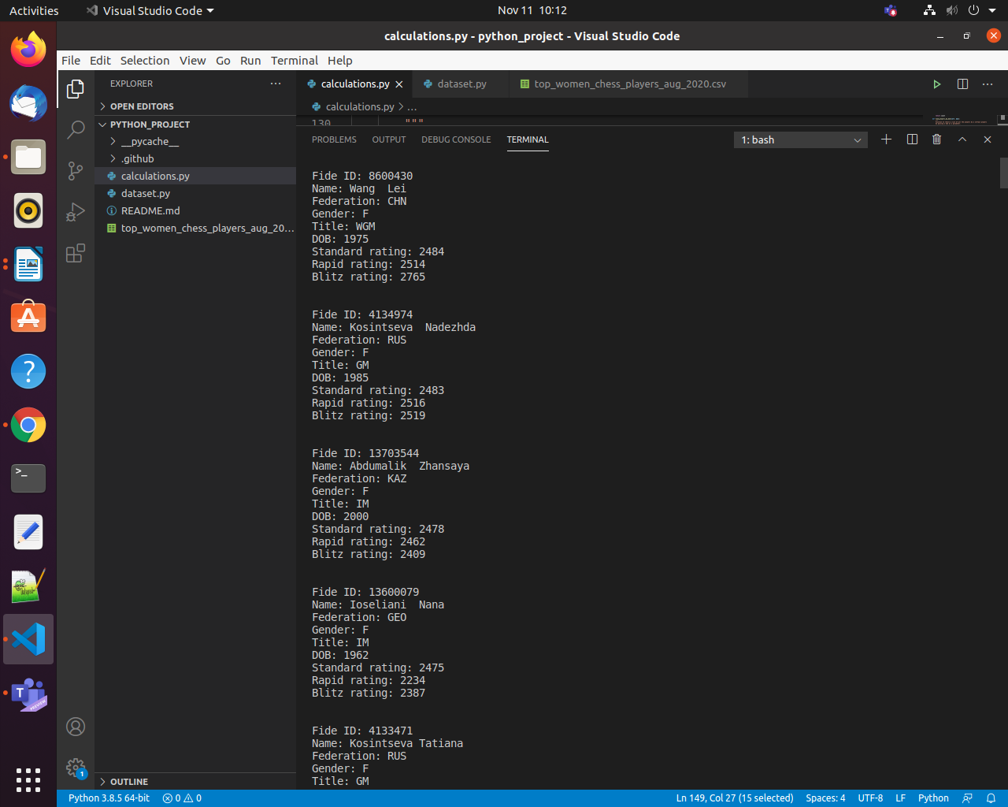

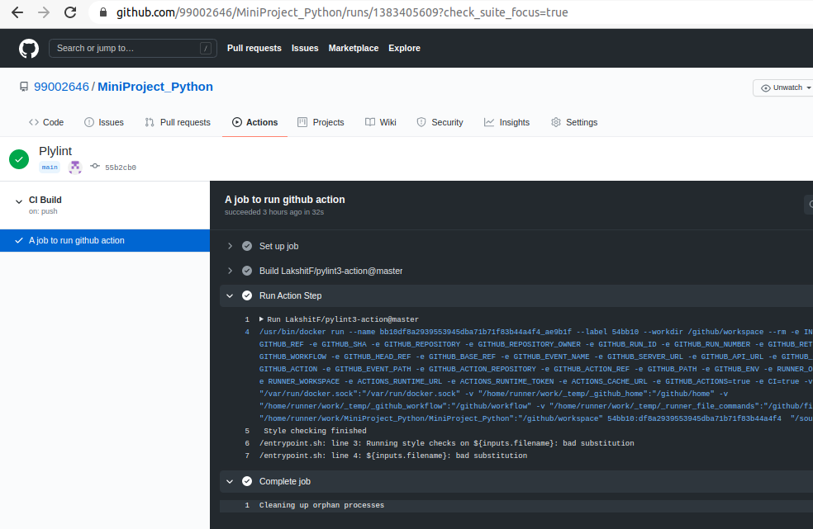Figure 19 : Bulid

#### Code quality and Issues or Bug Tracking

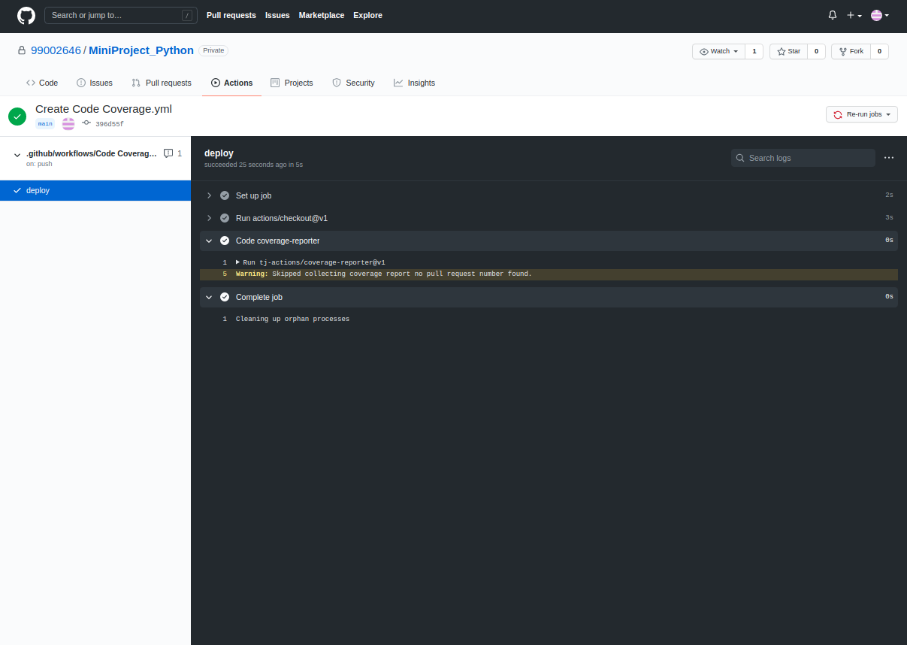

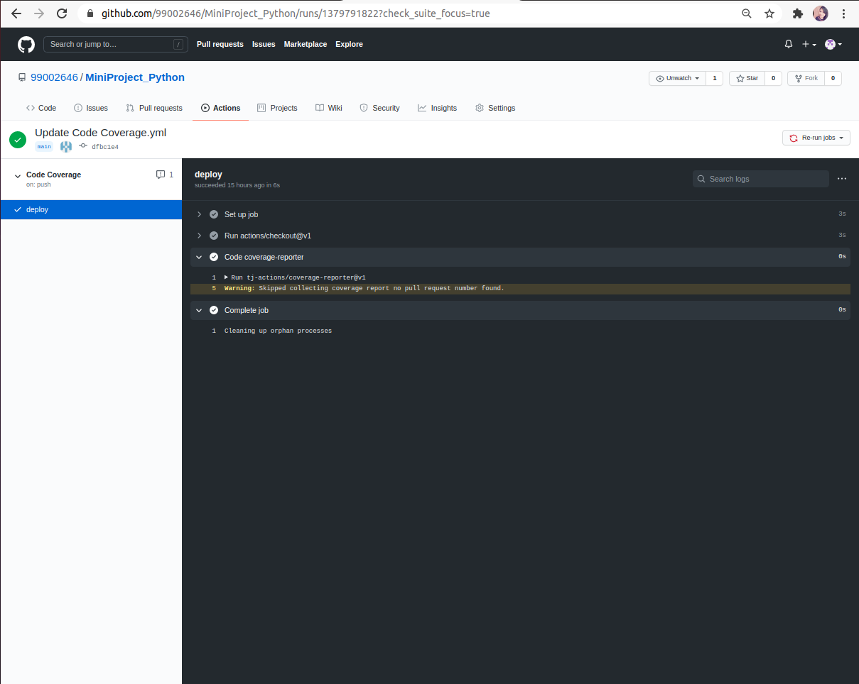

Figure 20 : Code Coverage

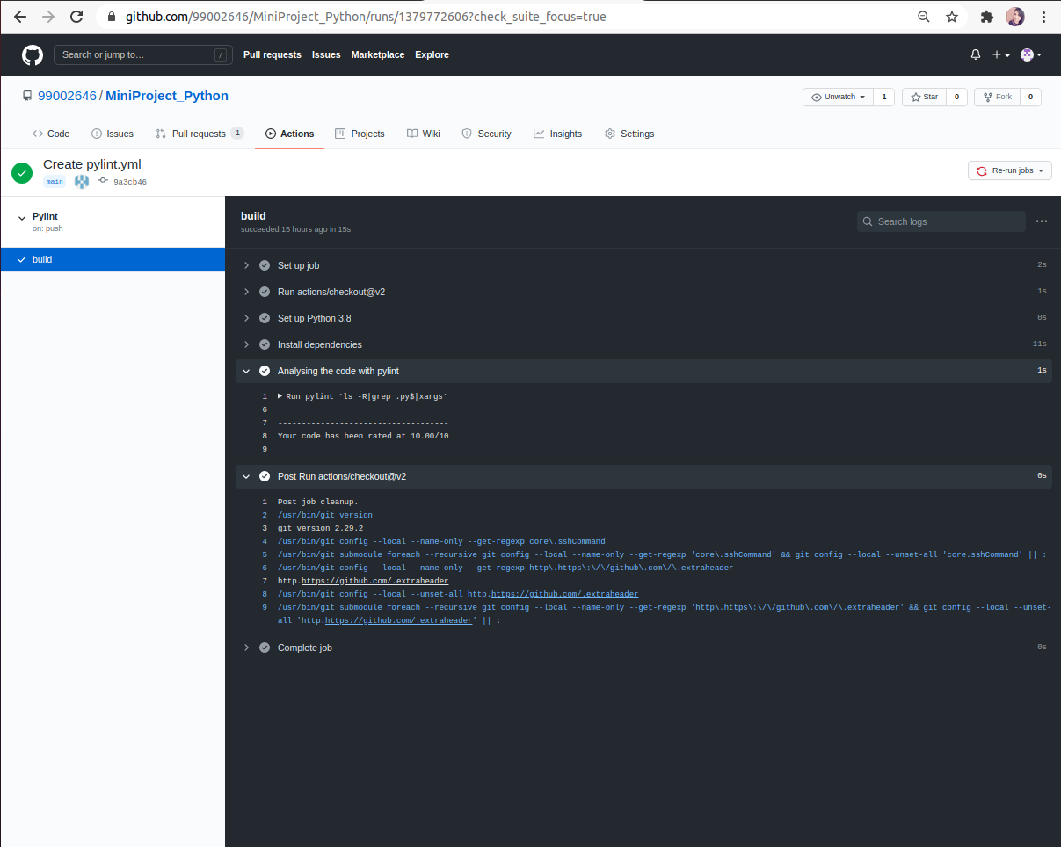

Figure 21 : Pylint

## **5.** **Individual Contribution & Highlights**

### 5.1 Challenges faced and how were they overcome

* While importing the data from the data set we have faced some of the problems with the particular row and columns.
* We have overcome that problem with trail and error.

### 5.2 Future Scope

* This project can be implemented further by adding some other features like displaying the players personal details if we give their Name or ID..

## **6. References**

[1] https://www.geeksforgeeks.org/introduction-to-linux-operating-system/

[2] https://www.w3schools.com/python/

[3] https://en.cppreference.com/w/

[4] <https://www.cplusplus.com/reference/>